Quiz Application Testing

Creating a new question in a database

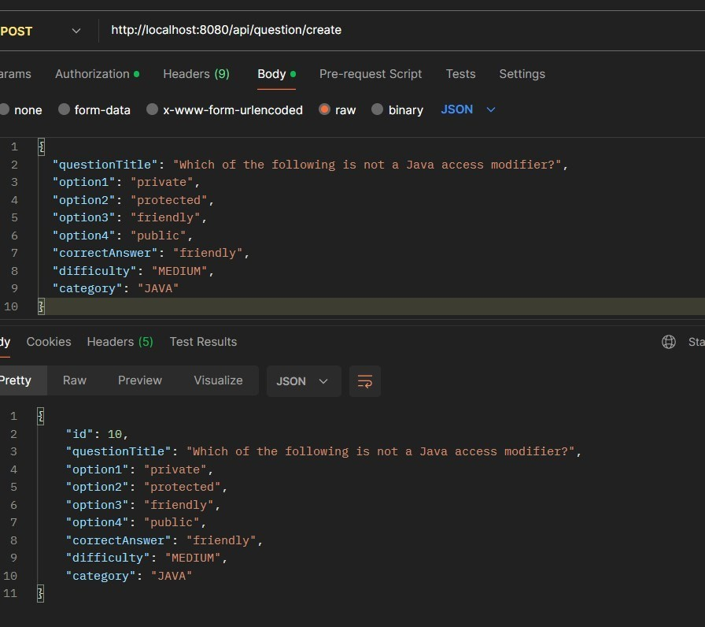

Creating a new quiz

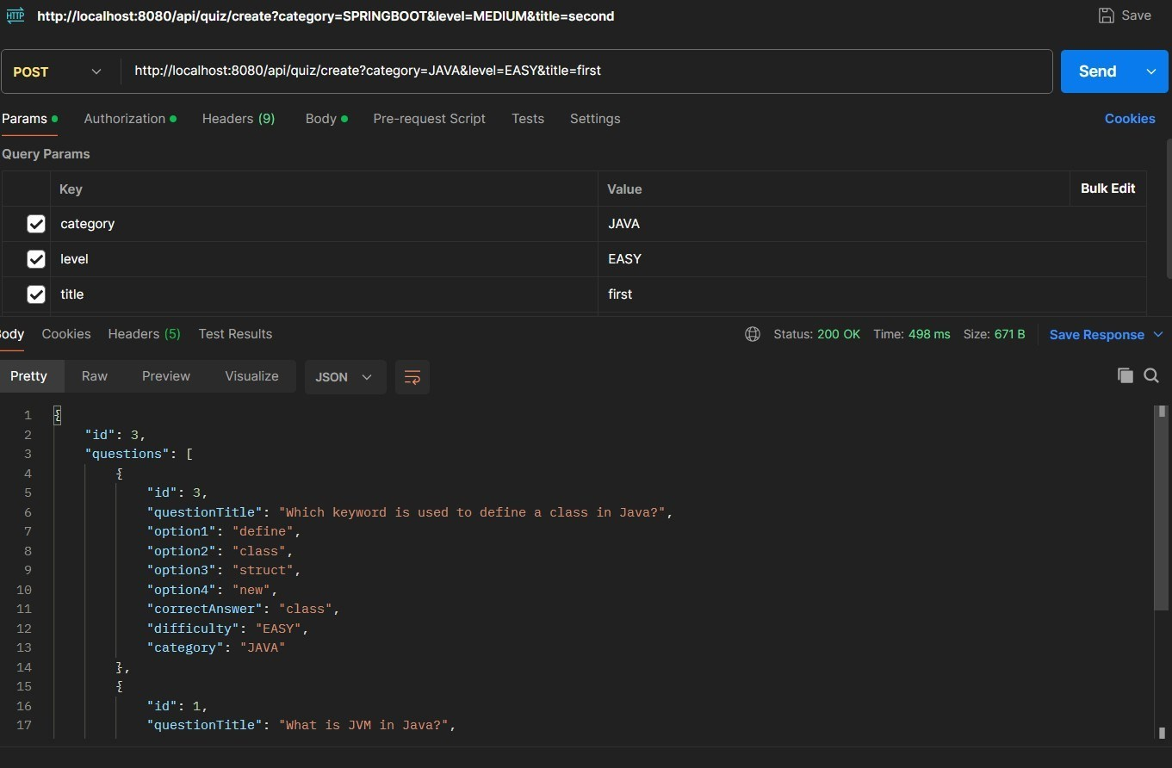

Getting questions to the user

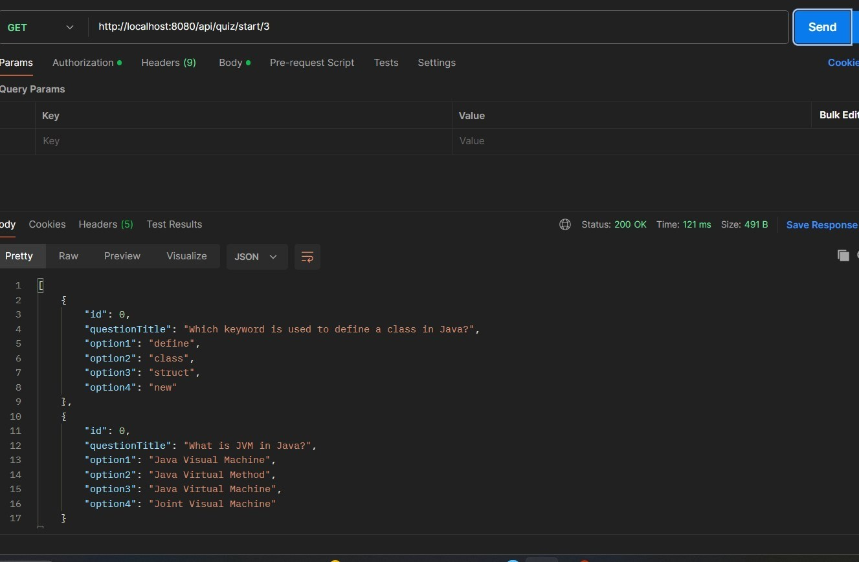

Getting Score of the user

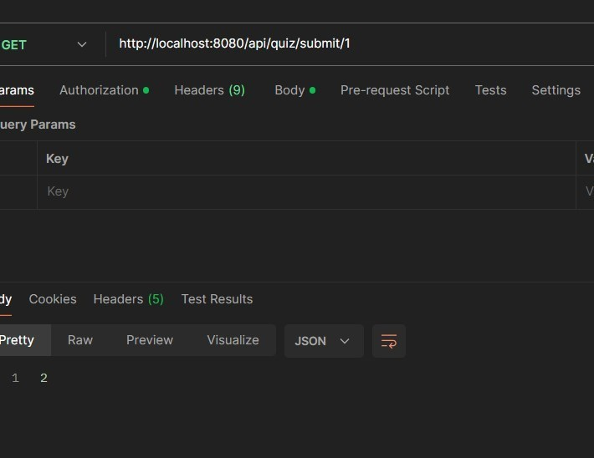

// sending wrong data it will throw exeception

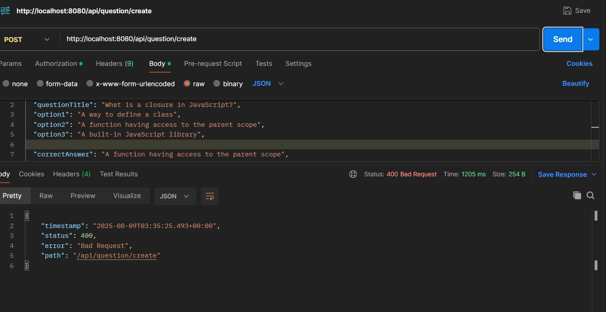

[0;39m Resolved [org.springframework.web.bind.MethodArgumentNotValidException: Validation failed for argument [0] in public com.wipro.venu.entity.Question com.wipro.venu.controller.QuestionController.createQuestion(com.wipro.venu.entity.Question): [Field error in object 'question' on field 'option4': rejected value [null]; codes [NotNull.question.option4,NotNull.option4,NotNull.java.lang.String,NotNull]; arguments [org.springframework.context.support.DefaultMessageSourceResolvable: codes [question.option4,option4]; arguments []; default message [option4]]; default message [option4 is required]] ]

// swagger API

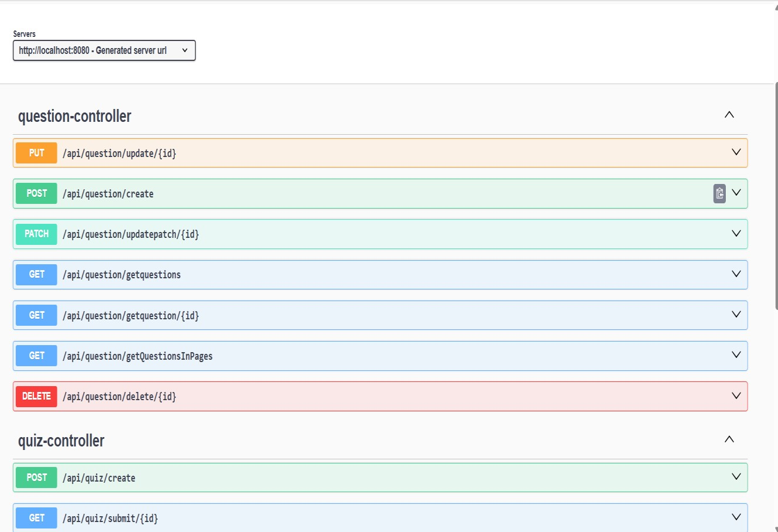

//API-Doc (http://localhost:8080/api-docs)

